Jenkins workspace for Web Service protocol:

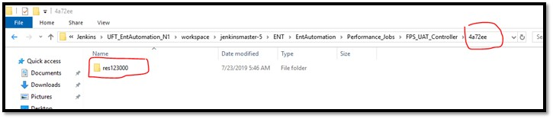

Jenkins workspace for WEB protocol:
